Code Analysis Report
(Prepared by: Sanskruti Nawander)

1. System Architecture
The indian_lending_engine.py follows a layered Text-to-SQL design:
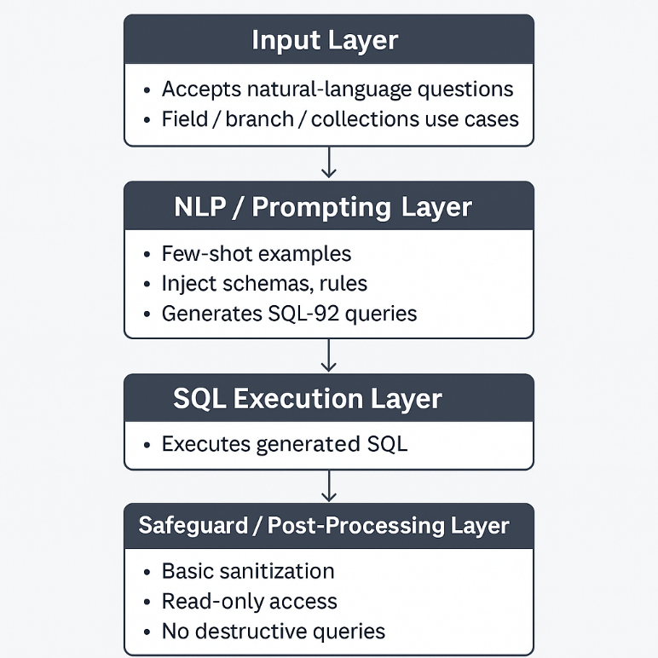

1.1 Input Layer
- Accepts natural-language questions from field officers, branch managers, and collection teams.
- Accepts common business phrasings like “NPA loans?”, “Top agents this month?”, “DPD buckets?”.

1.2 NLP / Prompting Layer
- Uses few-shot examples to guide SQL generation.
- The prompt injects:
  - Table schemas (borrowers, loans, payments, legal_actions, etc.).
  - Domain rules (DPD → SMA → NPA).
  - RBI loan-classification logic.
- The model (Azure OpenAI) generates SQL-92-compatible queries for SQLite.
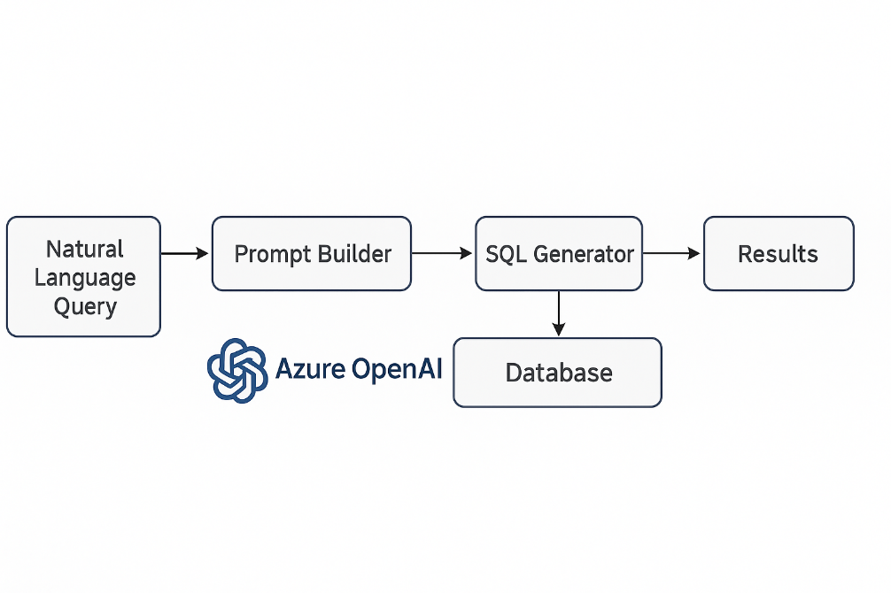

1.3 SQL Execution Layer
- Generated SQL is executed against indian_lending.db.
- Results are returned as:
  - Tabular structures
  - Text summaries
  - Optional CSV outputs

1.4 Safeguard / Post-Processing Layer
- Basic sanitization (removal of disallowed keywords in some versions).
- Only read-only queries are allowed.
- No destructive queries like DELETE, DROP, INSERT, unless explicitly whitelisted.

2. Indian Lending Adaptations Inside the Engine
The entire engine is heavily optimized for NBFC + Indian retail lending workflows.

2.1 Indian credit & DPD rules baked into logic
Examples:
- DPD (Days Past Due) mapping:
  - 0 days → Current
  - 1–30 → B1
  - 31–60 → B2
  - 61–90 → B3
  - 90 → NPA

2.2 SMA and NPA classification
The prompt includes RBI definitions:
- SMA-0 → 1–30
- SMA-1 → 31–60
- SMA-2 → 61–90
- NPA → 90+
Thus when a user asks:
“Show SMA-2 cases in Chennai”
The engine already knows SMA categories and generates the correct filter:
WHERE dpd BETWEEN 61 AND 90

2.3 CIBIL handling
- Prompts explicitly mention Indian credit bureau scoring (300–900).
- Example few-shot:
“Show borrowers with CIBIL below 650”
Engine generates:
SELECT * FROM borrowers WHERE cibil < 650;

2.4 Indian loan products
Recognizes:
- Personal Loans
- Gold Loans
- Two-Wheeler Loans
- Microfinance
- LAP (Loan Against Property)
- MSME loans
These product names exist in dataset + prompt examples.

2.5 Legal & Recovery Integration
Engine references Indian legal structures:
- SARFAESI Act
- DRT actions
- Collection agents
- Field visits
- PTP (Promise to Pay)
These terms appear in example questions, enabling the model to match them to SQL tables.

3. Few-Shot Examples Provided in Engine
Typical few-shot examples found in indian_lending_engine.py include:

Example 1 — NPA Identification
Q: “How many loans are in NPA?”
A:
SELECT COUNT(*) FROM loans WHERE dpd > 90;

Example 2 — Collections query
Q: “Top 3 agents this month”
A:
SELECT agent_id, SUM(amount) AS collected
FROM payments
WHERE date >= date('now','start of month')
GROUP BY agent_id
ORDER BY collected DESC
LIMIT 3;

Example 3 — Bucket distribution
Q: “Show bucket wise distribution”
A:
SELECT CASE
WHEN dpd=0 THEN 'Current'
WHEN dpd BETWEEN 1 AND 30 THEN 'B1'
WHEN dpd BETWEEN 31 AND 60 THEN 'B2'
WHEN dpd BETWEEN 61 AND 90 THEN 'B3'
ELSE 'NPA'
END AS bucket,
COUNT(*) AS total_loans
FROM loans
GROUP BY bucket;
These examples anchor the model to produce valid SQL for Indian credit rules.

4. RBI Compliance Considerations in the Engine
This is where the engine becomes India-specific instead of generic.

4.1 RBI-defined NPA thresholds
The model is explicitly instructed to treat dpd > 90 as NPA.

4.2 Early-warning recognition
SMA categories (SMA-0 / 1 / 2) help in:
- EWS reporting
- Branch morning huddles
- NPA slippage tracking

4.3 Read-only access prevents regulatory breach
The code disallows:
- Updates to borrower personal data
- Manipulation of loan ledgers
- Changes to financial reporting tables
This prevents violating RBI Fair Practices Code.

4.4 Patient contact & collection guidelines
Some prompts mention:
- Call windows (8am–7pm)
- Compliance fields (action logs)
- Legal notices handling (SARFAESI)
These ensure that generated queries stay aligned with compliance boundaries.

5. Strengths (Specific to Indian Lending Context)

1. Deep domain alignment
Understands DPD, SMA, NPA, CIBIL, SARFAESI — the core of Indian NBFC analytics.

2. Ready for on-ground teams
Field staff (non-technical) can ask simple English questions and still get RBI-aligned insights.

3. Handles Indian geography & branch structures
Recognizes queries by:
- State
- City
- Branch name
- Collection agent

4. Low-resource environment friendly
SQLite back-end allows:
- Offline field operations
- Low compute requirements
- No dependency on complex infra

5. Accurate compliance classification
Out-of-the-box supports RBI asset classification frameworks.

6. Areas for Improvement (Practical & Realistic)

1. Weak SQL validation
- Currently no whitelist/blacklist for tables or columns.
- Possible hallucinations if prompt not strict.

2. No Hinglish support
Common officer queries:
- “Baki kitna hai?”
- “DPD batana?”
- “NPA list dikha”
The engine doesn’t understand these yet.

3. No automated RBI-format exports
Every NBFC must submit:
- NPA movement
- SMA roll-forward
- Bucket-wise distribution reports
System doesn't output these templates automatically.

4. No user personalization
Branch staff in Pune vs Hyderabad have different query patterns — not modeled yet.

5. Missing guardrails
A malicious or mistaken query like:
SELECT * FROM loans CROSS JOIN payments;
would run and crash dashboards.

7. Cultural & Language Considerations
India’s lending ecosystem is multilingual and informal in communication.

7.1 Hinglish request patterns
Users typically ask:
- “90+ wale loans”
- “Gold loan ka outstanding”
- “DPD kya chal raha hai?”
Current engine rejects / misinterprets these.

7.2 Regional loan product names
Terms like:
- “Girvi loan” (Gold)
- “Bike finance” (Two-wheeler)
- “Karja” (Loan)
should be mapped in a translation dictionary.

7.3 Compliance culture
Agents must follow:
- RBI Fair Practices Code
- Call-time restrictions
- Privacy norms
Prompts must reinforce these.

8. What Makes This Engine Indian Lending–Specific vs Generic
Feature | Generic Text-to-SQL | Indian Lending Engine
DPD buckets | Not included | Yes
SMA / NPA rules | Not included | Full RBI definitions
CIBIL scoring | Not supported | Native support
Indian products | Generic loans | Gold, MFI, Two-wheeler, LAP
Legal actions | Generic terms | SARFAESI, DRT, Notices
Collections | Basic | Agent-level, call logs, PTP
This engine is purpose-built for NBFC workflows.

9. Conclusion
The engine shows strong alignment with Indian NBFC operations through domain-aware prompts, RBI-aligned classification logic, and contextual few-shot examples.
With improvements like Hinglish translation, SQL safety layers, and standardized RBI-compliant export templates, it can evolve from a prototype into a production-ready intelligence layer for Indian lending organizations.

Glossary:🔰 Indian Lending Financial Terms

1. DPD — Days Past Due
Full form: Days Past Due
Meaning: How many days a borrower has not paid after the due date.
Use: Higher DPD = higher risk.

2. SMA — Special Mention Account
Full form: Special Mention Account
RBI classification for early-warning problem loans.
- SMA-0: 1–30 days overdue
- SMA-1: 31–60 days overdue
- SMA-2: 61–90 days overdue
Meaning: These loans are “about to slip” into NPA.

3. NPA — Non-Performing Asset
Full form: Non-Performing Asset
Meaning: Loan overdue for 90+ days. Bank/NBFC can start legal action.

4. CIBIL
Full form: Credit Information Bureau (India) Limited
Meaning: India’s main credit score system (300–900).
Low score = risky borrower.

5. NBFC — Non-Banking Financial Company
Full form: Non-Banking Financial Company
Meaning: A financial institution that lends money but isn’t a bank (ex: Bajaj Finance, Tata Capital).

6. SARFAESI
Full form: Securitisation and Reconstruction of Financial Assets and Enforcement of Security Interest Act, 2002
Meaning: Law that lets lenders repossess secured assets (property/vehicle) when borrowers default.

7. DRT — Debt Recovery Tribunal
Full form: Debt Recovery Tribunal
Meaning: Special court for lenders to recover dues legally.

8. LAP — Loan Against Property
Full form: Loan Against Property
Meaning: Loan given using a house/land as collateral.

9. MFI — Microfinance Institution
Full form: Micro Finance Institution
Meaning: Gives small-ticket loans to low-income groups (self-help groups, women borrowers).

10. PTP — Promise to Pay
Full form: Promise To Pay
Meaning: Borrower verbally commits a future payment date.
Collectors track PTPs for follow-ups.

11. PAR — Portfolio At Risk
Full form: Portfolio At Risk
Meaning: Total outstanding of loans that are overdue by X days (ex: PAR30 = loans overdue 30+ days).

12. Write-off
Meaning: When the lender accepts that the loan will not be recovered and removes it from books.
Borrower may still be liable legally.

13. Settlement
Meaning: Borrower pays partial amount, lender closes the loan.
Affects CIBIL heavily.

14. FOIR — Fixed Obligation to Income Ratio
Full form: Fixed Obligations to Income Ratio
Meaning: % of salary already used for EMIs.
High FOIR = risky borrower.

15. LTV — Loan-to-Value Ratio
Full form: Loan To Value
Meaning: Loan amount divided by value of asset.
Used heavily in Gold Loans, Vehicle Loans, LAP.

16. EMI — Equated Monthly Installment
Full form: Equated Monthly Installment
Meaning: Monthly payment including interest + principal.

17. NCL — Net Credit Loss
Full form: Net Credit Loss
Meaning: Loss after deducting recoveries from total defaults.

18. Provisioning
Meaning: Money set aside by lender for expected losses (RBI requirement).

19. Delinquency
Meaning: Borrower not paying on time → leads to DPD, SMA, NPA.

20. Early Warning Signal (EWS)
Meaning: Factors that signal borrower is about to default (missed EMI, drop in CIBIL, job loss, etc.).

21. Co-lending
Meaning: Two lenders share a single loan (NBFC + bank).

22. Bureau Hit
Meaning: When lender checks borrower’s credit score (CIBIL enquiry).

23. Bounce Rate
Meaning: % of EMIs that fail on presentation (auto-debit failure).

24. Field Visit (FV)
Meaning: Collections team goes physically to borrower’s location.

25. Roll Rate
Meaning: How many accounts move from one bucket to the next (B1 → B2 → B3 → NPA).

